**KRBL Limited – Research Report**

**Overview of the company**: Biryani is one such thing which people thrives about. KRBL being the Basmati rice exporting company it is deep rooted with its brand India Gate. Biryani is famous in many countries and it has good demand. Basmati rice is the major component of biryani so obviously the product is having a good demand. Apart from that this company is world's largest exporter of basmati rice. India is the hub of basmati rice production and around 65% of global production comes from India**.**

**Shareholding Pattern of the Company:**

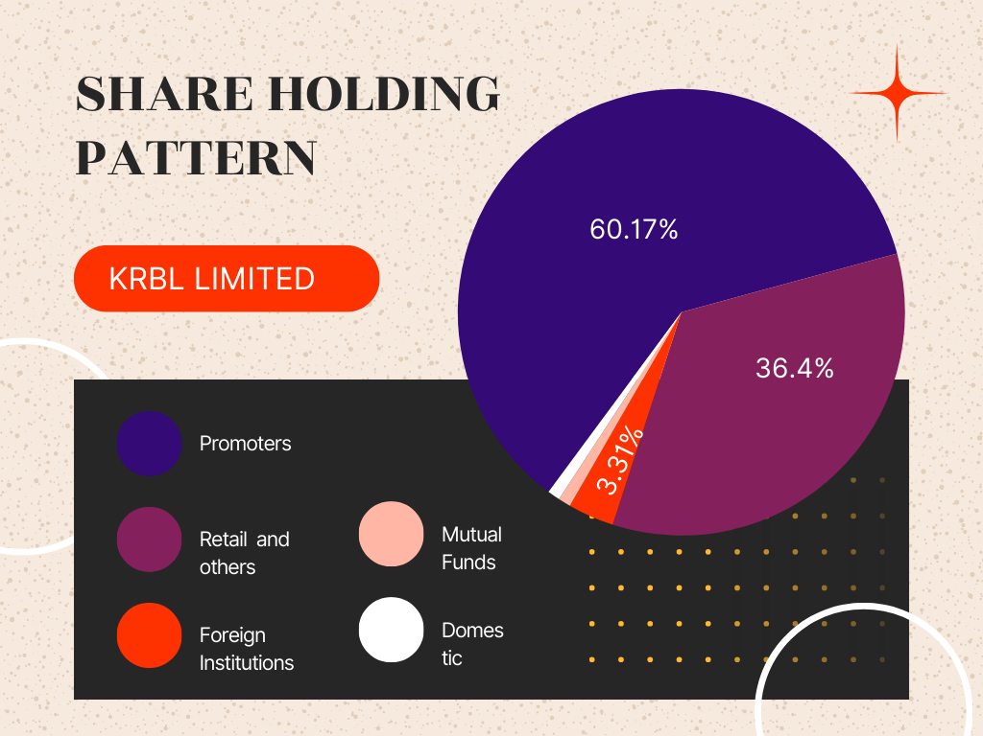

KRBL limited company’s shareholding pattern is shown in the pie diagram. The major shareholder of the company is promoters. Promoters held 60.17% share. Followed by Retailers and other Investors with 36.14%. Foreign Institutions participants held 3.31% share in the company. Mutual Funds has also held the share in the company with 0.05% share in the company. Domestic Institutions participation is very minute as they held 0.06%. Promoters and Foreign Institutions are having major share portion of the company.

**Management of the company:**

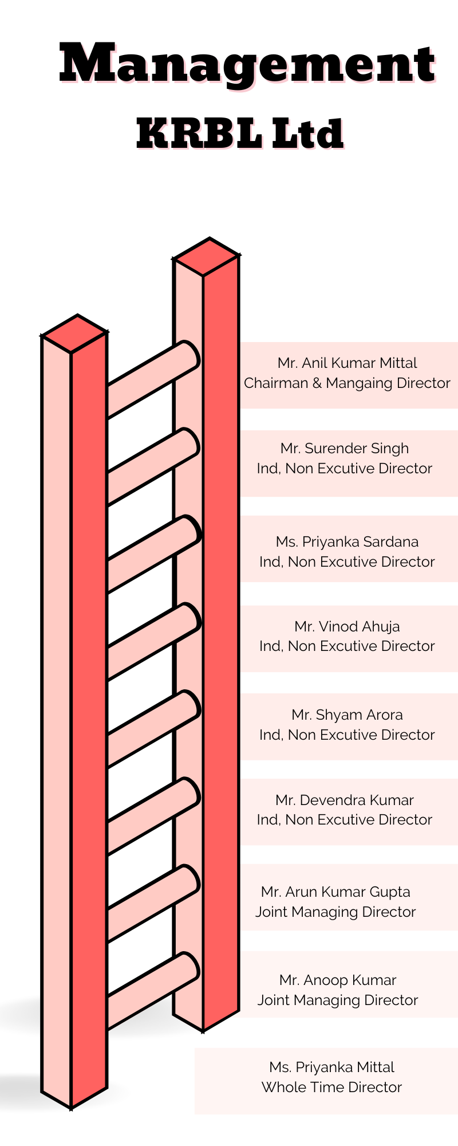

KRBL Limited is a family operated business with a legacy of over 130 years. In undivided India, two brothers — Khushi Ram and Behari Lal — wanted to bring quality essentials for customers. In 1889, they set up a small business dealing in rice, edible oil, and wheat in Lyallpur (now in Pakistan). The Management also includes the professional people and they are very experienced with the business.

**Brands & products of the company**:

KRBL limited has various brands in their portfolio. **India Gate, Unity, Nur Jahan, Zabreen, Others.**

India Gate alone contributes to 56.3% revenue to the company which is 3143 crores. Unity is next with Rs. 762 Crore, Nur Jahan with Rs.169 core and Zabreen with Rs. 135 Crore.

KRBL has other businesses as non-basmati rice, Health food segment and Power Generation.

**SWOT Analysis:**

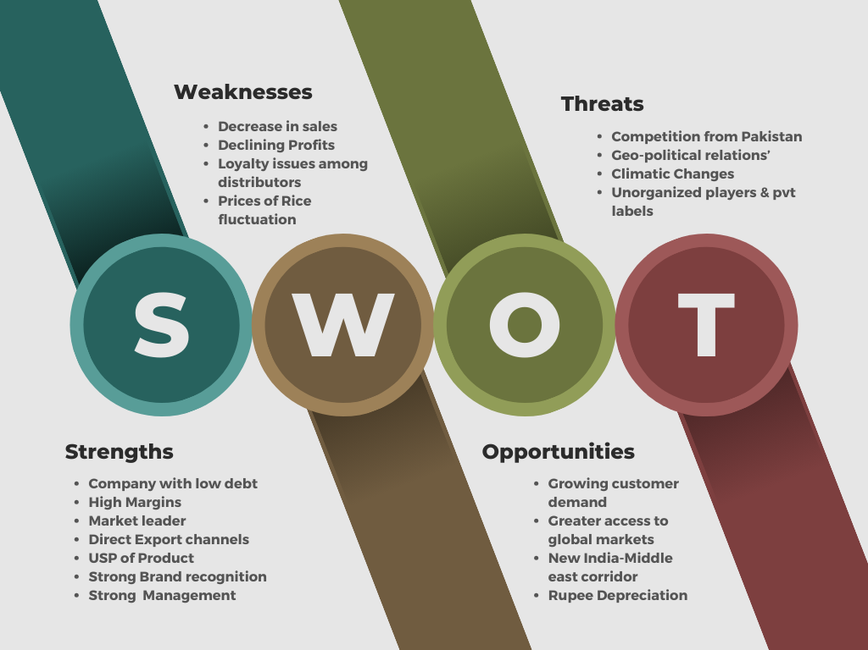

**Strengths:**

* **Company with Low debt**: KRBL Ltd company is having low debt. Its Debt-to-equity ratio is also good.
* **High Margins**: KRBL limited is facing the decline in the profitability but the margins of the company are higher than the other existing players in the industry.
* **Market Leader**: It is the Top producer and exporter of Basmati Rice. KRBL has its wings spread across the world.
* **Direct Export Channels**: KRBL Limited have direct export channels in more than 82 Countries and 500 distributors in India.
* **USP of the Product**: The perfect grains are with unique usp of 2 years of Ageing, which brings the best rice with perfect aroma, longest grains.
* **Strong Brand Recognition**: KRBL limited has its own brand named ‘’INDIA Gate’’ which is deep rooted into the hearts of the people of India and world as well.
* **Strong Management**: The Management with vast experience in the business makes it even stronger relatively compared to the other companies.

**Weakness:**

* **Decrease of the sales: KRBL limited** company’s sales were down 8.03% from 1319.28 Crore in sept 2022 to 1213 crore in sept 2023.
* **Declining profits:** The company’s profits are also being reduced as the sales went down. EBITDA also down compared to past year.
* **Misunderstanding Among Distributors:** The channels which the company has to distribute the products may sometimes go wrong due to affect the business.
* **Price of the Rice:** Rice prices always keeps on fluctuating owing the climatic situations and market demands.
* **High working capital:** The business usually need large capital as needs to procure the seeds, process and export the rice. It is vast process and involves huge capital infusion.

**Opportunities:**

* **Growing Customer demand:** Basmati rice is having unanimous demand across the world. People craving for biryani is too high.
* **Greater Access to Global Markets:**  The exports now became easier for the companies export to other countries as well.
* **Online Market:** The rapid explosion of the growth in online shopping and buying is also an advantage for the company.
* **New India Middle East Corridor:** The East corridor will connect India to West Asia/Middle East and the Northern corridor will connect West Asia/Middle East to Europe. By linking Asia, West Asia, the Middle East and Europe through enhanced connectivity and economic integration, the corridor aims to give a boost to economic development in the regions. **As the company is having export business in Middle East countries**, now it will become easier and less transportation cost which in return increases the Margins.
* **New Varieties for Export:** On the R&D front, the Indian Agricultural Research Institute has distributed a substantial quantity of basmati paddy seeds for seed multiplication and substitution.
* **Rupee Depreciation:** The depreciation of rupee will make India’s export cheaper. If prices drop it will increase the demand, hence It will help the export-oriented companies to increase their sales. This would be an opportunity for the KRBL Limited.

**Threats:**

* **Competition from Pakistan:** Basmati rice production is done in Pakistan, which is next biggest exporter for the basmati rice after India.
* **Geo Politics and International Relations:** As the company operates in several countries, whenever the miscommunication arises it will impact the business in large manner. Any geo-political disturbance will impact the trade of the company.
* **Climate changes:** The products are agricultural dependent and it mostly climate dependent. If the un expected changes occurs it will damage the produce, hence the production will be impacted.
* **Unorganised players & private labels:** The competition is heavier and also several companies with different price levels started trading and also giving tough competition in every aspect.

**Competitive Analysis**:

1. **LT Foods:**



* **LT Foods** is the company which sells basmati rice under the brand of DAAWAT. Daawat rice is growing at a pace faster than any other company. Company gives tough competition.
* **LT foods vs KRBL limited:** Krbl ltd company is facing tough competition with Daawat brand rice. In India almost in every state and every place people mostly choose India Gate or Daawat rice. They are deep rooted into the market with good brand recognition.
* **LT food Financials:** Though company’s revenue is lesser than the KRBL ltd. The company improving its market share gradually and also the profits of the LT foods rose 52.1% year-on-year at 152.65 Crore.
* **LT foods** is having good financials as compared to KRBL Ltd.

1. **Kohinoor Foods:**

* **Kohinoor Foods** is another company operating in the basmati rice segment. The company’s brand which it sells under is **Charminar.**
* **Financials of the company:** Kohinoor company revenue went down and it reported a loss of Rs. 3.6crore.
* **Sales** of the company also reduced and it is down 22.48% Y-O-Y at 22.03 Crore.
* The financial position of the company is not good as compared other companies in the segment.

**Conclusions of the Research:**

* KRBL Limited should focus on the weakness which company is having right now.
* It should build strong and loyal network of the distribution.
* Company should also focus on the sales and marketing.
* KRBL should also promote the brand even aggressively in order to retain their position as Market Leader.